Name: English 10: Art Analysis Ms. Myers

Directions: Study the two pieces of art provided. Pick one of the pieces of artwork and answer the questions below. If you want to switch between the two pieces that is fine, but make sure you identify which piece of artwork you are analyzing.

• Artist’s purpose/thesis: What is the message that the artist is trying to communicate? Artwork can often mean different things to different people; how could this piece be interpreted differently depending on the audience?

• Choice of medium: Why did the artist use the medium of the artwork? How does it add meaning or depth of message to the artwork? How would the artwork be different in another medium?

• Symbolism/Metaphor: What symbols are evident in the artwork? How is a symbol like a metaphor?

• How can artists effectively portray their opinions and perspectives? How is this different from using language?

• How can artists influence others through the use of art? What aspects of the craft can be changed or manipulated to send a message?

• Have the artists conveyed a message about their views on responsible world citizenship?

• What techniques can influence the way people look at the world and what is happening to it?

• How can artists use their craft to create and maintain the world they want to live in?

Frida Kahlo: *Self-Portrait, Between the Borderline of Mexico and the United States*

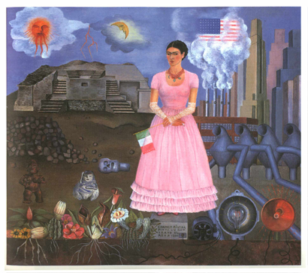

http://mati.eas.asu.edu:8421/ChicanArte/html_pages/kahlo5.lrgest.html

Salvadore Dali: *Melting clocks*

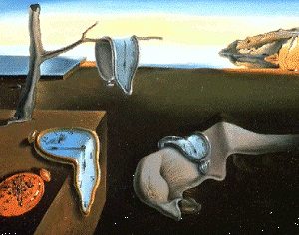

http://puffin.creighton.edu/museums/archive/9_mdesmarais/dali.gif